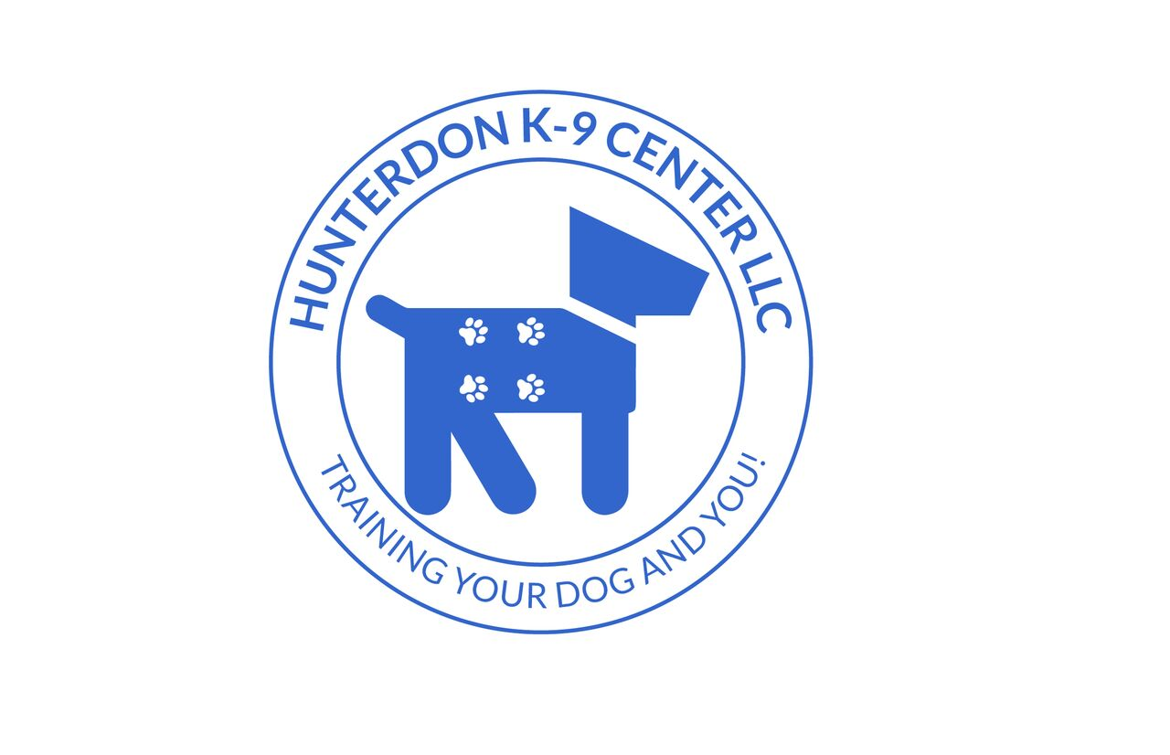
Hunterdon K9 Center  Plaza 12 West  631 Route 12  Flemington, NJ 08822  908-237-1389  hunterdoncaninecenter@yahoo.com  www.hunterdonk-9center.com  Please call or email for more information  Start dates are subject to change. Please call to verify. | Class Schedule  - Agility, Obedience, Scent Work and Conditioning/Confidence/Games Courses six-week session = $165.00  - Handling Class – Drop In only = $15 cash only

See website for enrollment/application form and inclement weather information

May / June 2019 New Session start dates

Monday Agility starts May 13, 2019

Monday Handling class drop ins continue May/June 2019

Tuesday AM Scent Work starts June 11, 2019

Tuesday PM Pet Obedience Level 1, Level 2 CGC/TDI, and Level 3 Reliable Recall, Impulse Control, Intro to Off Leash/Clicker Classes start June 11, 2019

Wednesday Competition Obedience starts May 22, 2019

Thursday Rally starts February May 30, 2019

Thursday Scent Work starts June 13, 2019

Friday Competition Obedience starts May 24, 2019

Saturday AKC S.T.A.R. Puppy and Confidence/Conditioning Classes start
June 29, 2019

